

3.11: Local Variables Walkthrough

This walkthrough shows what happens when we try to access variables which are local to a function. We are going to use the multiply_four_numbers() function for this demonstration. Enter the following code:

print(num_1)

Note: Make sure that this is not indented and, therefore, not part of the multiply_four_numbers() function.

Your code should be as follows:

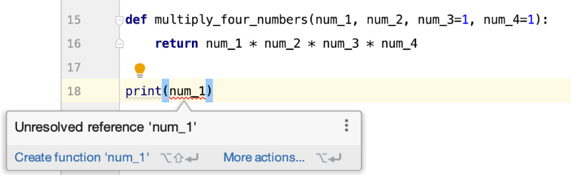

You will notice that PyCharm is giving you an error – “Unresolved reference ‘num_1’”. This is telling you that you are trying to use a variable which is not defined. However, you can see that it has been defined within the parameters for the multiply_four_numbers() function. Unfortunately, this variable only “exists” when the multiply_four_numbers() function is running – it is also only accessible to the multiply_four_numbers() function.

In PyCharm, we can ignore this error message and still run the program. This will produce the following error:

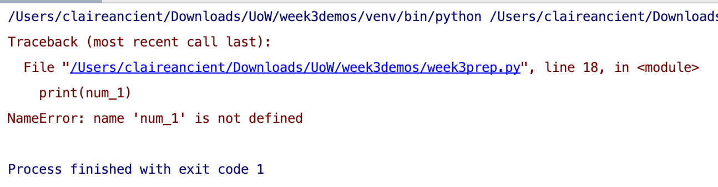

So, if you get the above error, it is telling you that you need to make sure that you define the num_1 variable (or whatever variable the error is referring to).